End users are able to save a partially-completed form by capturing the unique form URL. They may also choose to have this link emailed to them. When they are ready to revisit the form, they will simply click or paste the unique form URL into a browser, and the form will reload with any fields that had already been filled in. If they make any changes to the form, they will want to re-save and resend the form URL to themselves.

The link for saving a form can be found at the bottom of the live form.
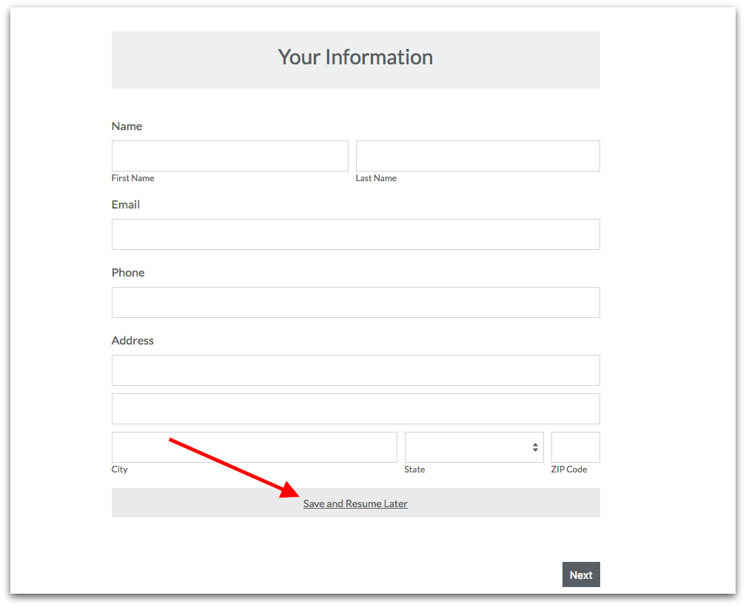

The user will have 30 days to return and finish filling out the form, after which time their data will be lost. This timer is reset every time the user re-saves the form. Once a Save and Resume link is made to finish the form and then click 'Submit', then the link will no longer be active.

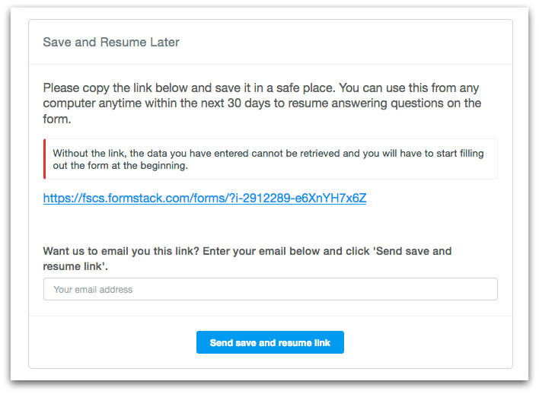

Save & Resume FAQs:
1. If someone loses the link to their partially completed form, can Formstack resend this to them?
A: At this time we do not have the ability to resend the links of partially completed forms.

2. Can I view forms that have not been submitted or check the status of these forms?
A: No, the partially completed forms and data are not visible until the form has been submitted to the database.

3. Do I need to save and send myself the link each time I work on the form?
A: Yes, if you fill out the form more, be sure you save and send yourself the updated URL link to the partially completed form, as this new link will contain the most recent changes.

4. If my form is embedded, will the Save & Resume link redirect them back to the embedded form?
A: At this time the Save & Resume function must send returning Users to a Formstack-hosted link where they can access their previously filled in form data.

